Report on the outcomes of a Short-Term Scientific Mission

Action number: CA18212
Grantee name: Krishna Khakurel

Details of the STSM
Title: Ultrafast X-ray Scattering of Cyclopentadine in Gas Phase with Megahertz X-ray Free-electron Laser
Start and end date: 01/02/2024 to 10/02/2024

Description of the work carried out during the STSM
Description of the activities carried out during the STSM. Any deviations from the initial working plan shall also be described in this section.
(max. 500 words)
The STSM was to participate in the ultrafast X-ray scattering experiments at Stanford Linear Accelerator Laboratory, led by Prof. Martin Centurion from University of Nebraska. The experiments were carried out between 1st of February to 10th of February at the Coherent X-ray scattering beamline. The sample for the proposed experiment was cyclopentadine (CP). We probed the structural dynamics of CP by the femtosecond X-ray beams. The molecules were injected to the X-ray beams in the gas phase. CP in gas phase were excited by the near UV wavelengths and the signature of the following structural dynamics were recorded in the X-ray scattering patterns.
During the experiment, a power scan was performed to ensure that all the signatures of the ultrafast dynamics are seen in the single photon ionization regime. An instance of such power scan is shown in the figure below (fig 1). Further, the scattering at different time-series was collected to observe the structural dynamics predicted by the simulations. Fig.2 shows the normalized difference intensity of the scattering pattern at different time scales fitting with the predicted simulation.
I involved actively in the planning and the data analysis during the experiment. This provided an overview of the ultrafast X-ray scattering experiments in the gas phase, the potentials and the nature of data, which will be helpful in extending my own research with Ultrafast X-ray scattering experiments. This was the primary goal of the STSM.

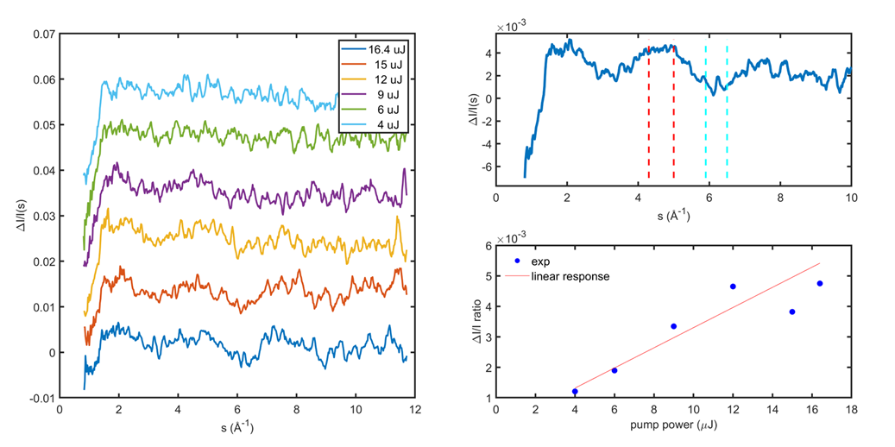
Figure 1 The power scan and the corresponding scattering profile; Plots showing that the dynamics was collected in single photon regime

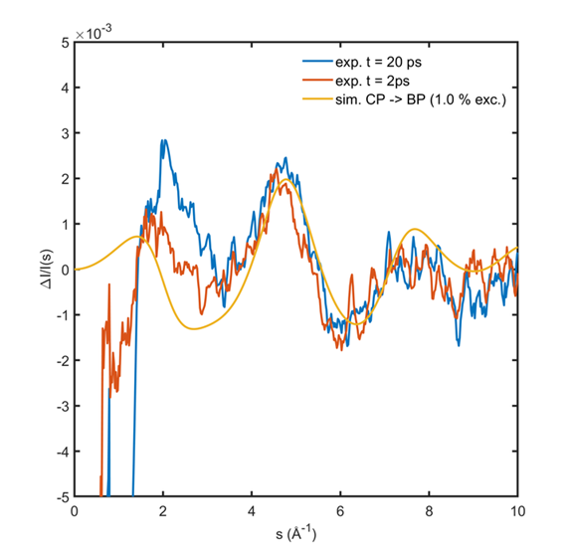
Figure 2 The scattering Profile at different time and it's comparison with the theoretical calculation
Description of the STSM main achievements and planned follow-up activities
Description and assessment of whether the STSM achieved its planned goals and expected outcomes, including specific contribution to Action objective and deliverables, or publications resulting from the STSM. Agreed plans for future follow-up collaborations shall also be described in this section.
(max. 500 words)
The goal of the STSM was met. The primary objective of the STSM was to participate in the ultrafast X-ray scattering experiments, get hands on experience on the gas phase experiments and data analysis and to induce new collaborations. All these were done during the STSM. Some exciting result has been obtained during the STSM stay in SLAC ultrafast X-ray scattering experiment. An international team including the grantee is carrying out the data analysis. We expect a very good publication coming out of the experiments.
The extended goal of the STSM is to start using the ultrafast X-ray scattering for grantees’ own research. In order to do that the grantee has discussed several projects with the beamline staffs and collaborators. Some of these projects are currently under discussion for submitting the proposal in the upcoming call for the experiments.
The experience gained during the STSM will also be useful in several experiments that the grantee shall be doing with the in-house ultrafast X-ray sources. Several of such experiments are in the schedule for the current year.
To summarize, the STSM has given a new direction to the grantees’ research. Several experiments, which the grantee has been looking forward to do in last few years, will become more real and feasible with the experience gained and the collaborations made during the STSM.

This report is submitted by the grantee to the Action MC for approval and for claiming payment of the awarded grant. The Grant Awarding Coordinator coordinates the evaluation of this report on behalf of the Action MC and instructs the GH for payment of the Grant.

